**EX: Hydrolic system**

Simulate given hydrolic sytem using Matlab&Simulink.

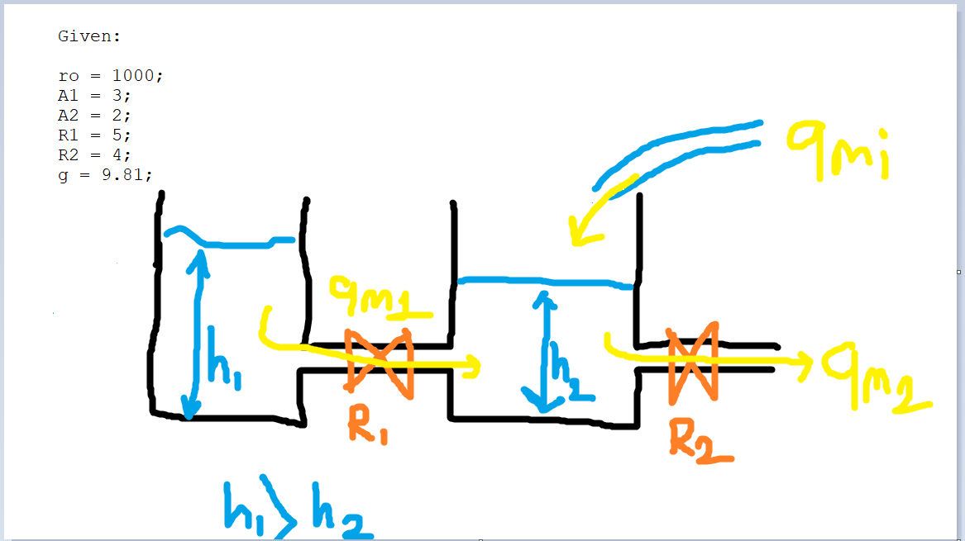

(fig.1. Hydrolic tanks representation)

**1) Determining equations**

Before simulation, equations and Transfer functions should be determined. Here, we need to know the law of conservation of mass .

🡪 🡪 (Eq. A1)

🡪 🡪

(Eq. A2)

Then, determine using equation 1:

(Eq. 1.1)

Then, determine using equation 2:

(Eq. 2.2)

Then, rewrite the equations 1.1 and 2.2 in the s-domain form:

(Eq. 1) (Eq. 2)

Then, rewrite Eq.1 and Eq.2:

(Eq. 1’)

(Eq. 2’)

**2) Extraction of transfer functions with Matlab codes**

After all of this, it’s easy to determine transfer functions using Eq.1 , Eq.2 , Eq.1’ and Eq.2’ . Let’s determine transfer functions of and using following matlab codes.

%% Matlab Codes

clear all;

close all;

clc;

syms s ro A1 A2 R1 R2 g H1_s H2_s %here; Write variables

%For real values . Use these values in your Problem.

ro = 1000;

A1 = 3;

A2 = 2;

R1 = 5;

R2 = 4;

g = 9.81;

H2_s = H1_s * ( (s + g/(R1*A1)) / (g/(R1*A1)) ); %here: We defined H1_s uing Equation 1'

Qmi_s = (H2_s*(s + g/(R1*A2) + g/(R2*A2)) + H1_s*(-g/(R1*A2))) / (1/(ro*A2)) %here: Lets find Qmi_s using following code line

%Now, lets determine TF of H1(s)/Qmi(s) following code

H1_Qmi_tf = H1_s/Qmi_s; %This code will find TF of H1(s)/Qmi(s)

pretty(collect(H1_Qmi_tf,s)) %This code will rewrite

Calclated transfer function:

syms s ro A1 A2 R1 R2 g H1_s H2_s %here: we write variables again

%For real values

ro = 1000;

A1 = 3;

A2 = 2;

R1 = 5;

R2 = 4;

g = 9.81;

H1_s = H2_s / ((s + g/(R1*A1)) / (g/(R1*A1))); %here: we defined H1_s uing Equation 1'

Qmi_s = (H2_s*(s + g/(R1*A2) + g/(R2*A2)) + H1_s*(-g/(R1*A2))) / (1/(ro*A2)) %here: Lets find Qmi_s using following code line

%Now, lets determine TF of H2(s)/Qmi(s) following codes

H2_Qmi_tf = H2_s/Qmi_s;

pretty(collect(H2_Qmi_tf,s))

Calclated transfer function:

You can find the screenshots of the codes from the figures below.

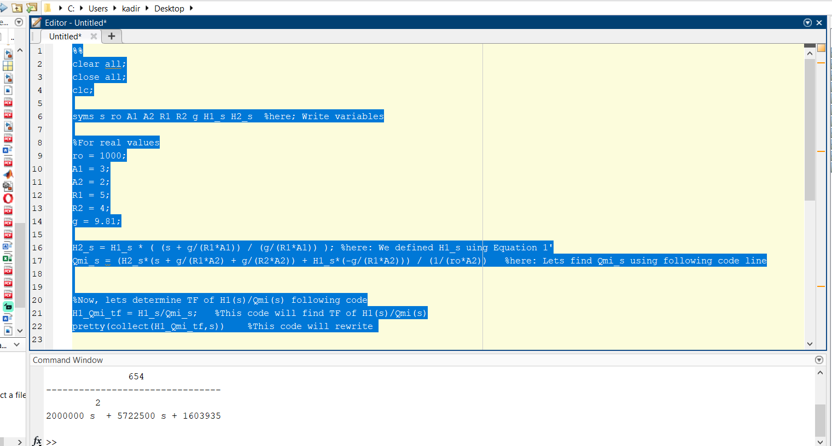

(Fig.2. Transfer Function codes of H1(s)/Qmi(s) )

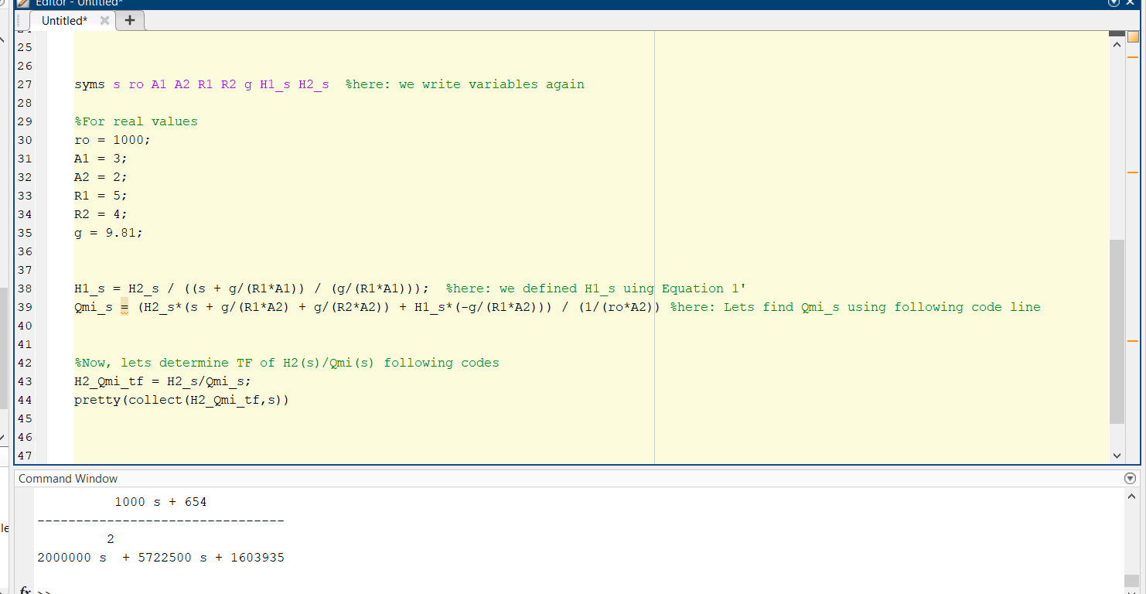

(Fig.3. Transfer Function codes of H2(s)/Qmi(s) )

**3) Simulating the extracted transfer functions in Matlab Simulink environment and the results**

- The dynamic behavior of the system has been observed by using the Sin Wave block according to the values given in the figure below.

metin, yazılım, bilgisayar simgesi, multimedya yazılımı içeren bir resim

Açıklama otomatik olarak oluşturuldu

(Fig.4. Values of Sin Wave and Simulink environment)

metin, ekran görüntüsü, öykü gelişim çizgisi; kumpas; grafiğini çıkarma, çizgi içeren bir resim

Açıklama otomatik olarak oluşturuldu

(Fig.5. Scope of Sin Wave)

- The dynamic behavior of the system is observed by using the Constant block according to the value given as 100 kg/s in the figure below. If a flow of 100 kg/s can be provided to the system, the system will reach equilibrium after approximately 13 seconds, as observed.

ekran görüntüsü, metin, yazılım, multimedya yazılımı içeren bir resim

Açıklama otomatik olarak oluşturuldu

(Fig.6. Behavior of the system at a constant value)

**4) Extracting the state-space equation**

Use equations 1.1 and 2.2

(Eq. 1.1)

(Eq. 2.2)

State-Space Matrix

**5) Simulink model of state-space equation**

here is the modeling of the system according to state-space.

diyagram, dikdörtgen, plan, çizgi içeren bir resim

Açıklama otomatik olarak oluşturuldu

(Fig.7. Simulink model)

Matlab function codes are below.

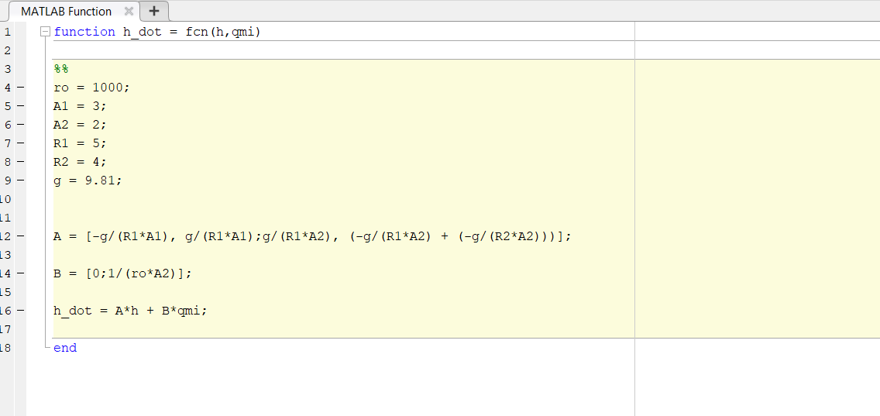

(Fig.8. Matlab Function codes)

As observed, matlab function outputs and transfer function outputs are the same according to the same inputs.

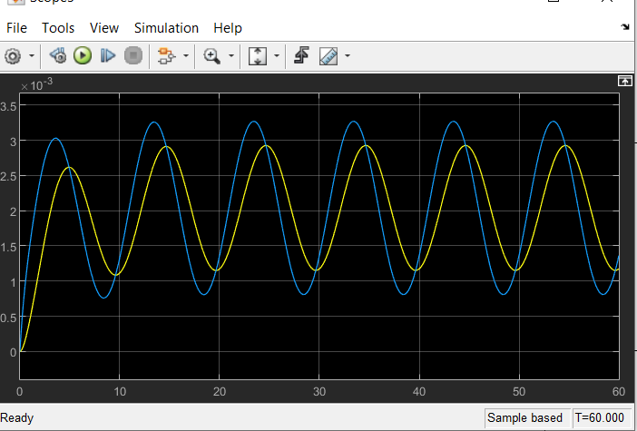

(Fig.8. Sin Wave result)

ekran görüntüsü, multimedya yazılımı, yazılım içeren bir resim

Açıklama otomatik olarak oluşturuldu

(Fig.9. Constant result)

Assuming that the system has "Initial Conditions", we can change the h1 and h2 values from the "integrator" as shown in the figure.

metin, ekran görüntüsü, yazılım, ekran, görüntüleme içeren bir resim

Açıklama otomatik olarak oluşturuldu

(Fig. According to ICs )

Let's look at the behaviour of the system according to the ICs (h1=2m and h2=1m) given above.

ekran görüntüsü, multimedya yazılımı, yazılım, metin içeren bir resim

Açıklama otomatik olarak oluşturuldu

(Fig Scope of the system according to previous ICs )

Finally, in the figure below, we can see the h1 and h2 values from 2 separate models in 2 separate scopes.

metin, ekran görüntüsü, yazılım, bilgisayar simgesi içeren bir resim

Açıklama otomatik olarak oluşturuldu

(Fig. Models)

The results of the above simulink model are in the figure below.

ekran görüntüsü, metin, multimedya yazılımı, grafik yazılımı içeren bir resim

Açıklama otomatik olarak oluşturuldu

(Fig. Results of 2 models)

**7) Conclusion**

As a result, we can observe the dynamic behaviour of the hydraulic tank system upon modelling. In this way, we can evaluate in advance what parameters should be considered in the tank system to be designed (for example, the floor areas of the tanks (A), the resistance of the tanks in the flow (R), the initial conditions (h)).